SMART HOME AUTOMATION USING ESP32 AND BLYNK

Abstract
Smart Home Automation is an Internet of Things (IoT) based project that enables users to control home appliances remotely through a mobile application. In this project, an ESP32 microcontroller is connected to the Blynk IoT platform through Wi-Fi. Two LEDs are used to simulate household appliances, where LED1 represents a light bulb and LED2 represents a fan. Users can control these appliances using the Blynk mobile application. This project demonstrates the implementation of IoT technology for remote monitoring and control of home devices without requiring physical hardware appliances.

Introduction
The Internet of Things (IoT) is a technology that enables communication between devices through the internet. Smart Home Automation is one of the most common applications of IoT. It allows users to control and monitor household appliances remotely using smartphones.
This project uses an ESP32 microcontroller because it has built-in Wi-Fi capabilities, making it suitable for IoT applications. The Blynk IoT platform provides an easy-to-use interface for controlling appliances through a mobile application.

Objectives
The main objectives of this project are:
- To develop a smart home automation system using ESP32.
- To remotely control household appliances using a smartphone.
- To understand IoT communication between devices and cloud platforms.
- To implement wireless control using Wi-Fi technology.
- To simulate real-world smart home applications.

Components Used
Hardware Components
1. ESP32 Development Board
2. LED 1 (Represents Light/Bulb)
3. LED 2 (Represents Fan)
4. Two 220Ω Resistors
5. Jumper Wires
Software Tools
1. Wokwi Simulator
2. Arduino IDE
3. Blynk IoT Platform
4. Wi-Fi Network

Why ESP32?
ESP32 is selected because:
- Built-in Wi-Fi support.
- Low power consumption.
- Fast processing speed.
- Supports IoT applications.
- Easy integration with Blynk.
- Cost-effective and widely available.

SYSTEM ARCHITECTURE

Mobile App (Blynk)

↓

Blynk Cloud

↓

Wi-Fi

↓

ESP32

↓

GPIO Pins

↓

LED1 (Light) and LED2 (Fan)

CIRCUIT CONNECTIONS
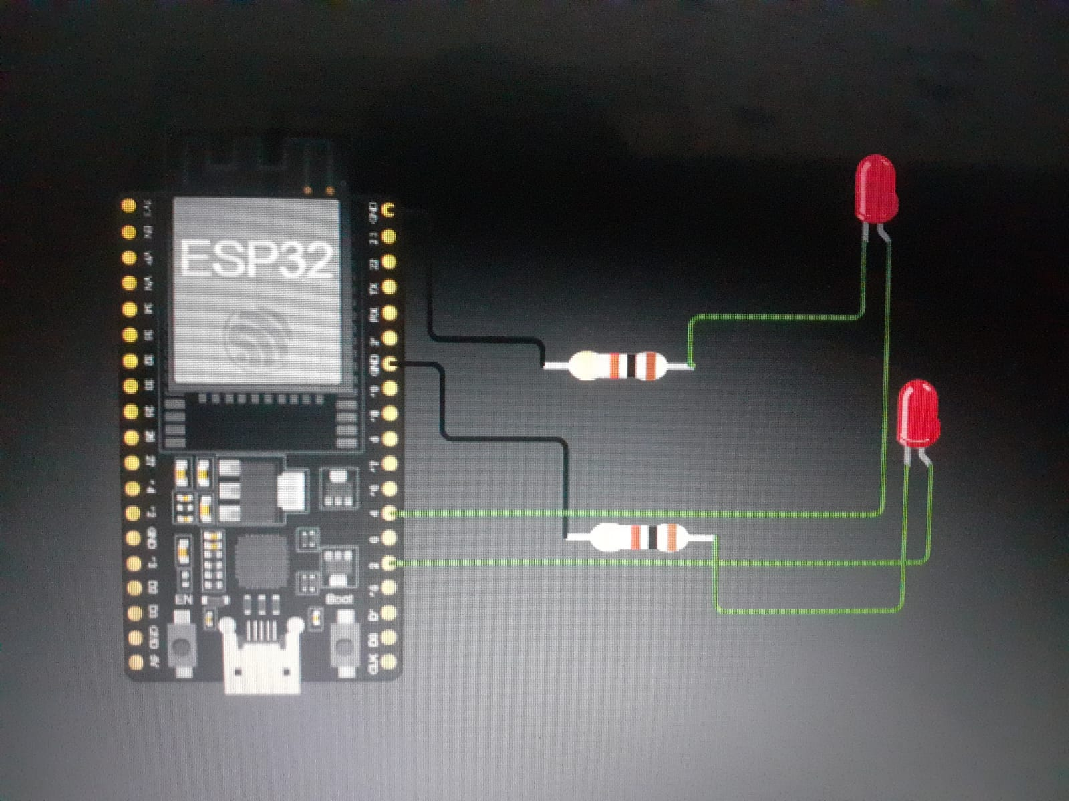
LED1(Light/Bulb)
GPIO2 → LED1 Positive Terminal
LED1 Negative Terminal → Resistor → GND
LED2 (Fan)
GPIO4 → LED2 Positive Terminal
LED2 Negative Terminal → Resistor → GND
WORKING PRINCIPLE
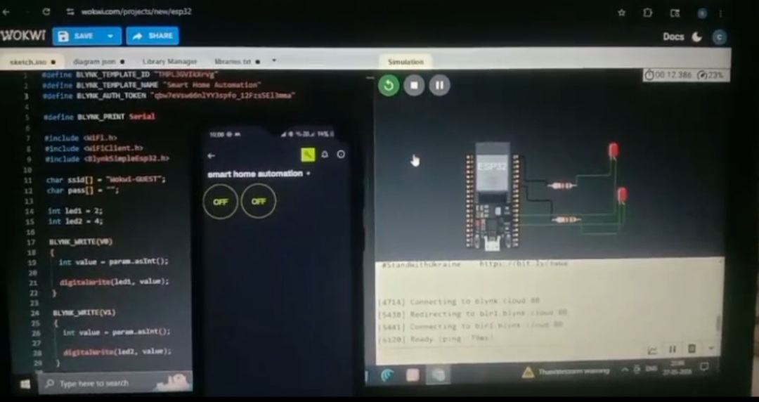
1. ESP32 connects to Wi-Fi.
2. ESP32 connects to the Blynk cloud server.
3. User presses buttons on the Blynk mobile application.
4. Commands are transmitted through the internet.
5. ESP32 receives the commands.
6. GPIO pins are switched HIGH or LOW.
7. LEDs turn ON or OFF accordingly.
8. LED1 represents a Light/Bulb and LED2 represents a Fan.
BLYNK CONFIGURATION
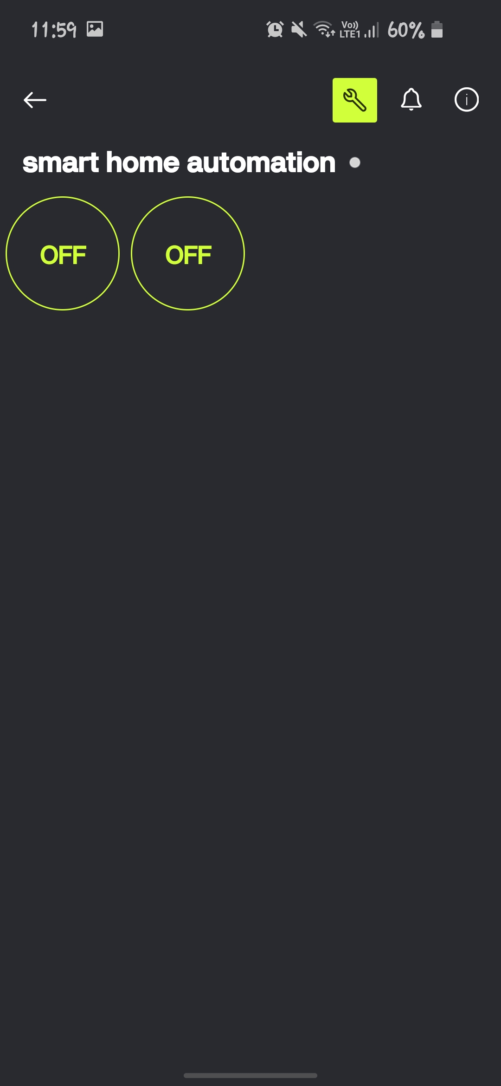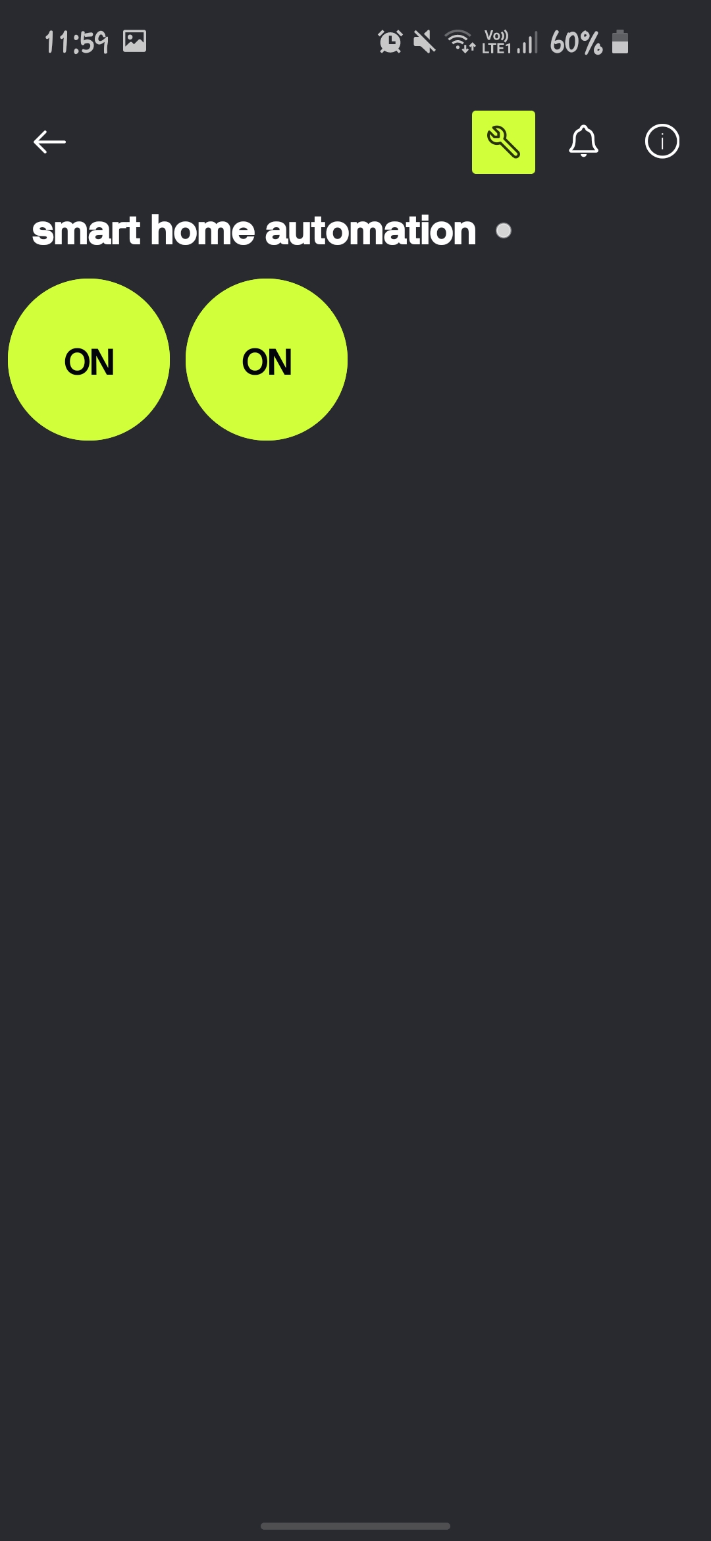
Template Name
Smart Home Automation
Hardware
ESP32
Connection Type
Wi-Fi
Virtual Pins
V0 → Light Control
V1 → Fan Control
Widgets Used
- Button Widget for Light
- Button Widget for Fan
ALGORITHM
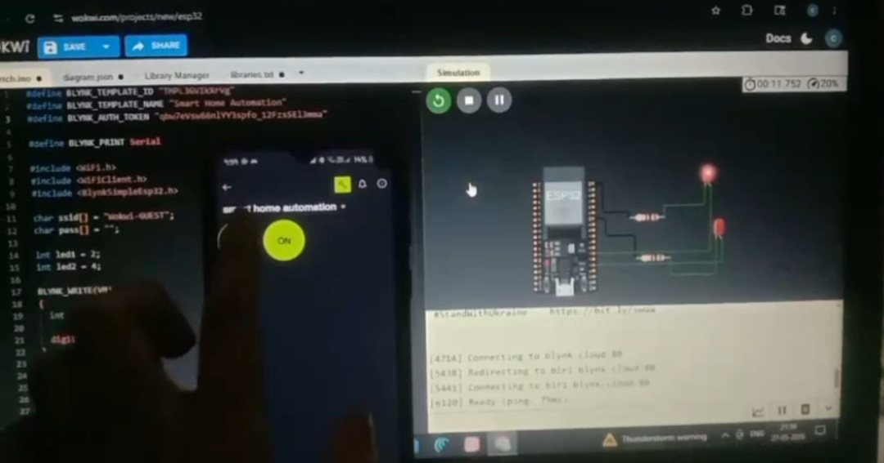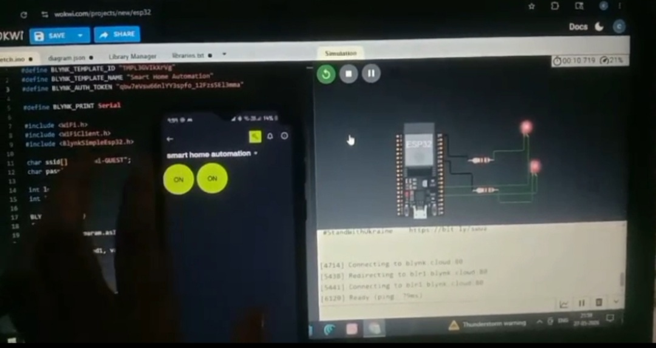
Step 1: Initialize ESP32.
Step 2: Connect ESP32 to Wi-Fi.
Step 3: Connect ESP32 to Blynk Cloud.
Step 4: Configure GPIO2 and GPIO4 as outputs.
Step 5: Read user commands from Blynk.
Step 6: If V0 is ON, turn ON LED1.
Step 7: If V0 is OFF, turn OFF LED1.
Step 8: If V1 is ON, turn ON LED2.
Step 9: If V1 is OFF, turn OFF LED2.
Step 10: Repeat continuously
FEATURES
- Remote appliance control.
- Wi-Fi-based communication.
- Mobile application interface.
- Real-time operation.
- Low-cost implementation.
- Easy scalability.
APPLICATIONS
- Smart Homes
- Smart Offices
- Industrial Automation
- Energy Management Systems
- Elderly Assistance Systems
ADVANTAGES
- Easy to use.
- Wireless operation.
- Remote accessibility.
- Reduced manual effort.
- Flexible and scalable design.
- Supports future IoT expansion.
LIMITATIONS
- Requires internet connectivity.
- Depends on cloud services.
- Security measures are required for real-world deployment.
RESULTS
The Smart Home Automation system was successfully implemented using ESP32 and Blynk IoT. The user was able to remotely control simulated appliances through the Blynk mobile application. LED1 successfully represented a light bulb, while LED2 represented a fan. The system demonstrated reliable IoT communication and real-time appliance control.
FUTURE ENHANCEMENTS
- Voice-controlled automation.
- Motion sensor integration.
- Temperature monitoring.
- Smart energy management.
- Google Assistant integration.
- Alexa integration.
- Home security monitoring.
CONCLUSION
The Smart Home Automation project successfully demonstrated the use of IoT technology for remote appliance control. ESP32 provided reliable Wi-Fi connectivity, while the Blynk platform enabled easy interaction through a mobile application. The project illustrates how IoT can improve convenience, efficiency, and automation in modern homes. This implementation serves as a foundation for developing advanced smart home systems.

